Date format validation testing.

Results view:

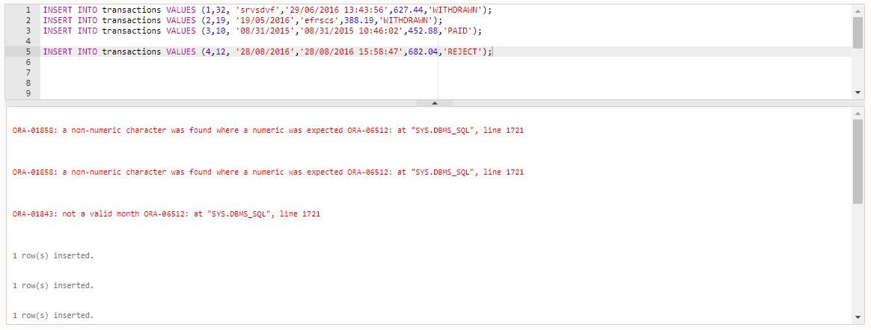

Testing for the validity of the transaction amount, it should not be zero or negative.

Results view:

